- Process Synchronization and Child Process Monitoring Using waitpid().
Code: #include <stdio.h>
#include <unistd.h>
#include <sys/wait.h>

int main() {
pid_t pid = fork();

if (pid == 0) {
printf("Child process running...\n");
sleep(2);
printf("Child process finished.\n");
} else {
printf("Parent waiting for child...\n");
waitpid(pid, NULL, 0);
printf("Parent continues.\n");
}

return 0;
}
output:
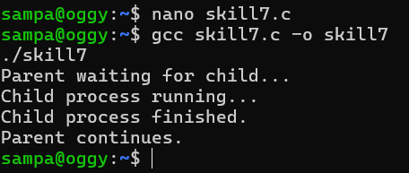

To Retrieve PATH Variable, Parse Search Directories, Locate Executables, Verify Permissions, Handle Missing Commands, Test Command Resolution.
code: #include <stdio.h>
#include <unistd.h>
#include <sys/wait.h>

int main() {
pid_t pid = fork();

if (pid == 0) {
printf("Child PID: %d\n", getpid());
return 5;
}

int status;
waitpid(pid, &status, 0);

if (WIFEXITED(status))
printf("Child exited with status: %d\n",
WEXITSTATUS(status));

return 0;
}
output:


